**Lists**

* List is a “type” of data just like string and integers
* It is a collection of values similar to arrays in some other languages
* Python uses zero-based indexing, meaning the first index is 0
* *Python Power: You can mix different types of elements inside a single list!
* To ***define*** a new “list a” with 3 elements:

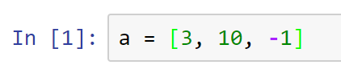

* To ***display*** the elements of a list

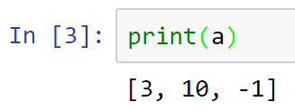

* To ***add*** an item to a list, use the append() method
* Note the use of the dot notation

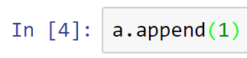

* Note that the new element is added (appended) to the end

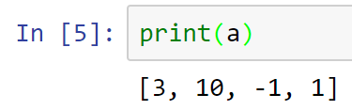

* There are many predefined functions that you can use against a list
* Research Python manual for other useful methods
* You may ask, where is the manual? Guess where it will be in this Knowledge-Creating Era?
* As mentioned earlier, you can ***mix*** different types in a list

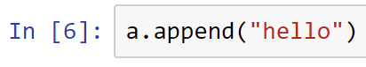

* Verify your new list

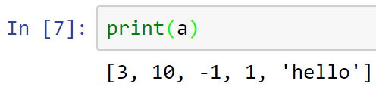

* Cool, huh?
* Think of what you can do with this data structure!
* A list could also contain other lists

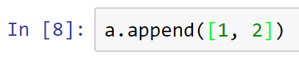

* Check out how your new list looks!

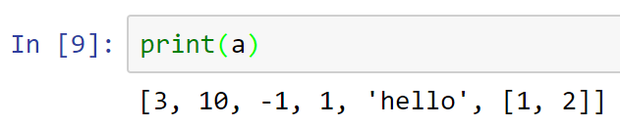

* To ***delete*** the last item in a list

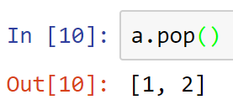

* Note how pop() method returns the deleted element
* To see the new list

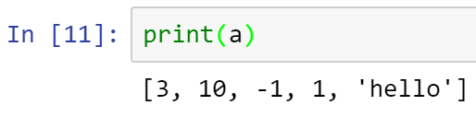

* What if you want to retrieve a specific item from this list?
* Python is zero-based language, so the first element will have index 0
* Also, in jupyter notebook, you don’t need to issue a print() statement to display
* To display or ***retrieve*** the first element in “list a” do the following

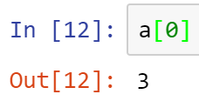

* However, to keep the syntax consistent across different IDE, use print() function

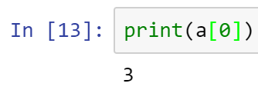

* Note that you get the same result
* To ***replace*** the element in a list
* Select the element in the list, and assign a new value

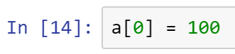

* The code above changed element 1 (i.e., subscript 0) to have a value 100
* Verify that the item has been replaced

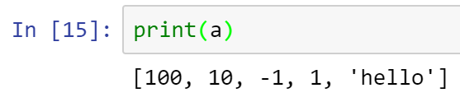

* Swapping elements in a list
* Suppose you want to swap the two elements below

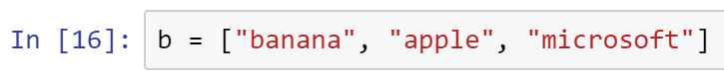

* Note the structure of a list in Python, each element refers to a value

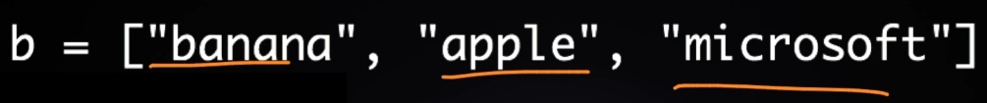

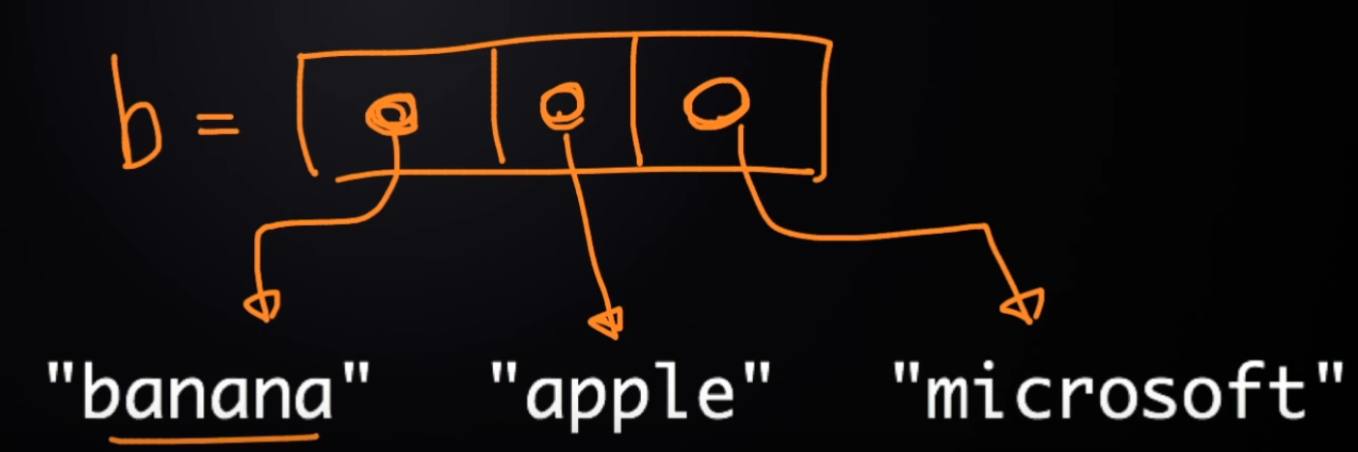

* Here’s how you swap the first two elements

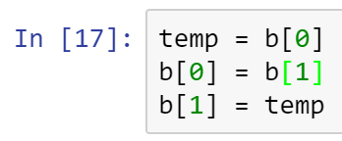

* Make sure that the swap operation works

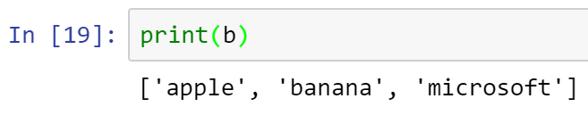

* Challenge: Research what is another way of swapping elements in a Python list.
* Place your answer here below:

____________________________________________________________________________

* You may use negative index to access a list backward
* 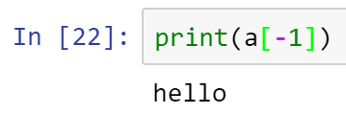
* Note that -1 is the index to the last entry (the right-most element)

**List slicing**

* [ start : end ]
* inclusive exclusive
* 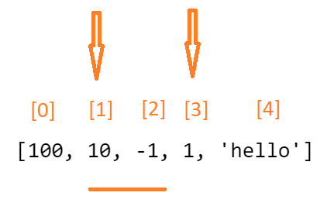
* 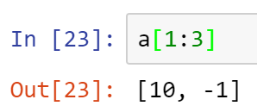
* 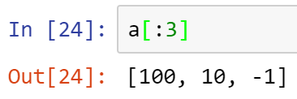
* 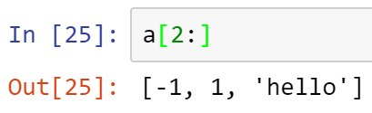
* **Changing** multiple elements in a list
* 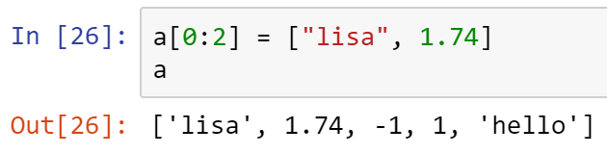
* **Adding** multiple elements
* 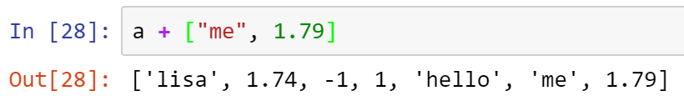
* Deleting an element in the list
* 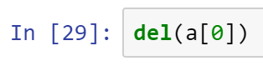
* 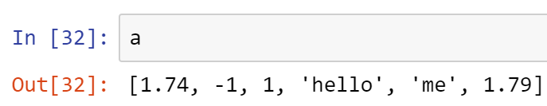

**Passing the reference**

* 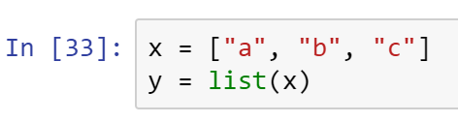
* 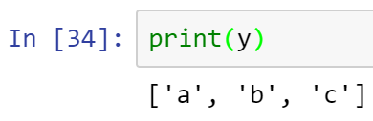
* Copy all your code into a Word doc, place your name on it, and submit in Canvas.